CLASS
Installation and Basic Operation Manual

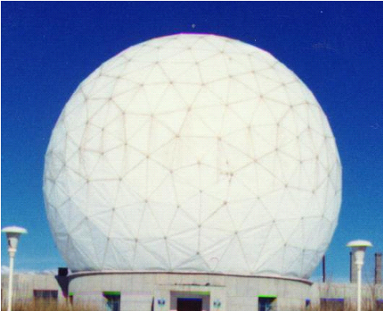li

Qinghai Radio Astronomical Station
Purple Mountain Observatory Academia

Веб-сайт: www.dlh.pmo.cas.cn
Millimeter-wave radio database: ：
www.radioast.nsdc.cn or www.radioast.csdb.cn
e
GILDAS - Installation and Basic Operation Manual
GILDAS（Grenoble Image and Line Data Analysis System）Is IRAM development A set of software for processing single line observations of spectral data and interference data.

First, the installation:
Now the installation is much simpler than before, not too much trouble.

1, in the window system to install, as long as through http://iram.fr/IRAMFR/GILDAS/ Download the latest version gildas-win-*.msi To the local hard drive, double-click the installation on it, windows under the same software installation. Installation After the run, you can in the Start menu, click Class, etc., usually, is not recommended, the best through cmd, cd Into the directory where you store the data, run the command class and so on.

Second, GILDAS basic use of the order

1. ASTRO command

ASTRO is an observing use program that uses it to derive the time position information for various sources and prepare for observation.

DEV IMAGE WHITE/BLACK // Open an X-WINDOWS terminal
CATALOG filename // Open the file filename and read the source table information
OBSERVATORY 97: 43: 44.1 37: 23: 26.0 3.2 // Coordinate of the Observatory's location
TIME 3:00 19-JAN-2002 // Observed date and time (world time)
HORIZON /SOURCE
RULE X /MAJOR // Draw the time grid
HORIZON 15 15/SOURCE // Generates a time position map of the source in the sky

As shown below:

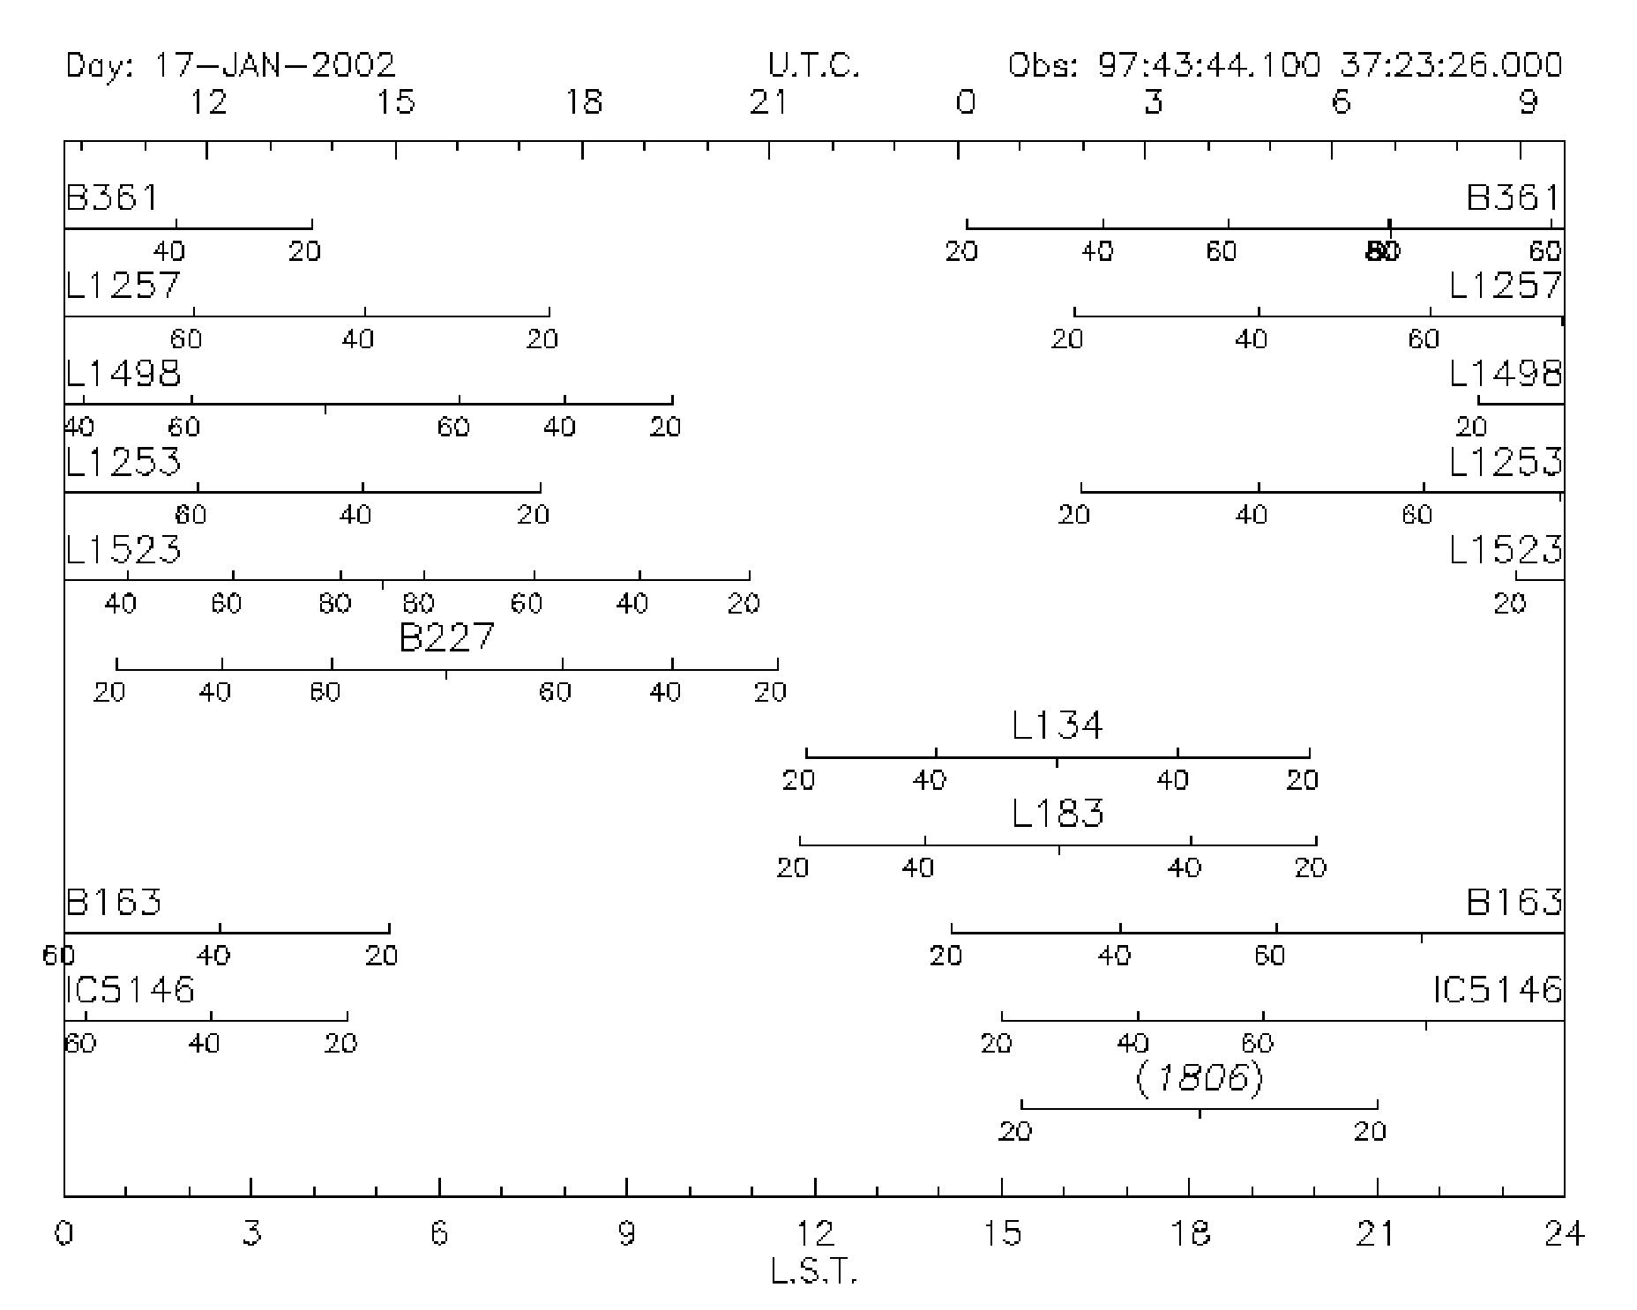

CONVERT filename /J2000 // coordinates converted to J2000, and saved to the current directory filename file
CONVERT filename /B1950 // coordinates converted to B1950 and saved to the current directory filename file
CONVERT filename /GALACTIC // coordinates are converted to bank coordinates and saved to the current directory filename
File
CONVERT filename /PRECESS year // coordinates are converted to any year's coordinates and saved to filename
FRAME HOR S // Draw the ball coordinate system
SOURCE /DRAW // Draw the position of the source in the sphere coordinate system
HEAD // write the message

The results are as follows:

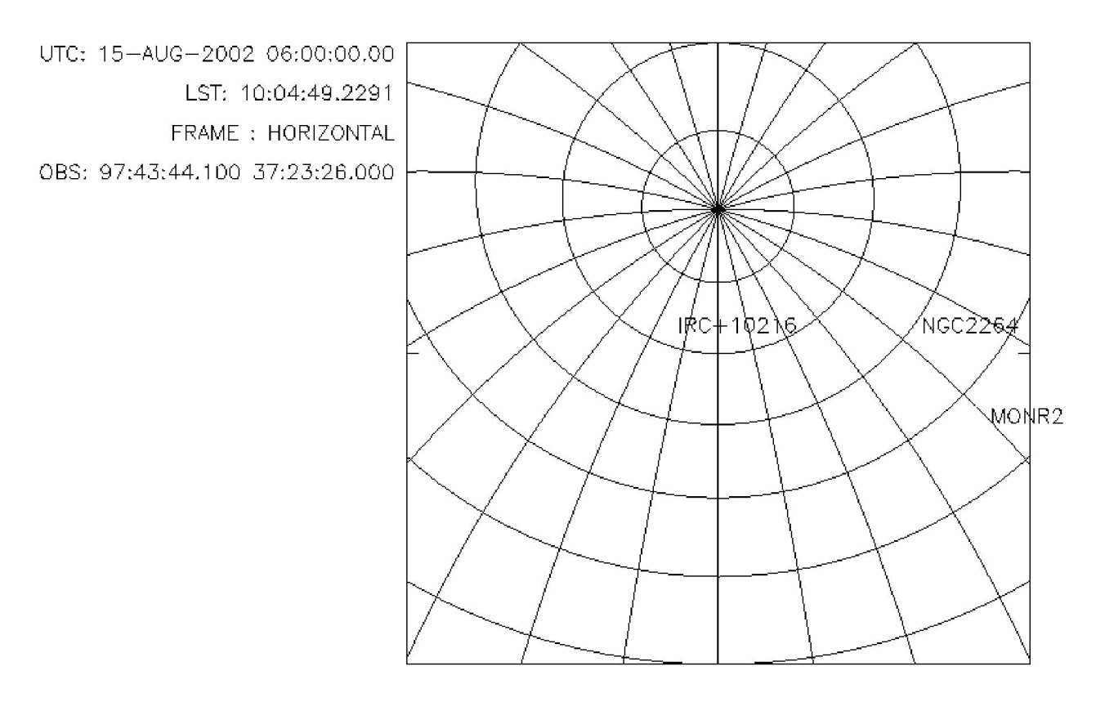

HOR /PLANET // Generates the time position of the planet in the sky

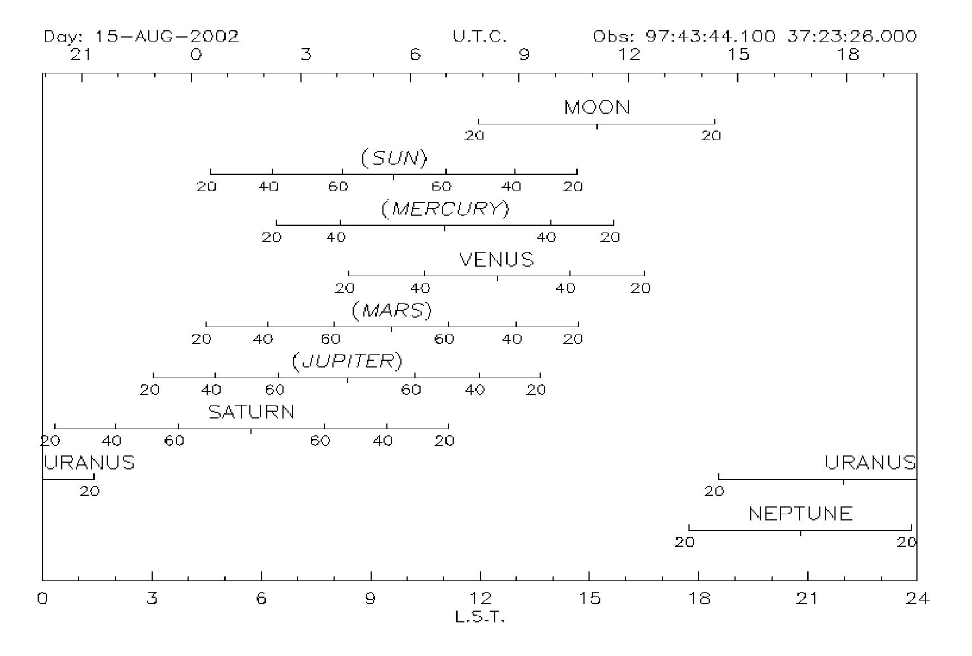
Note: The format of the file is:
Source name EQ Epicentral declination LS speed
as follows:

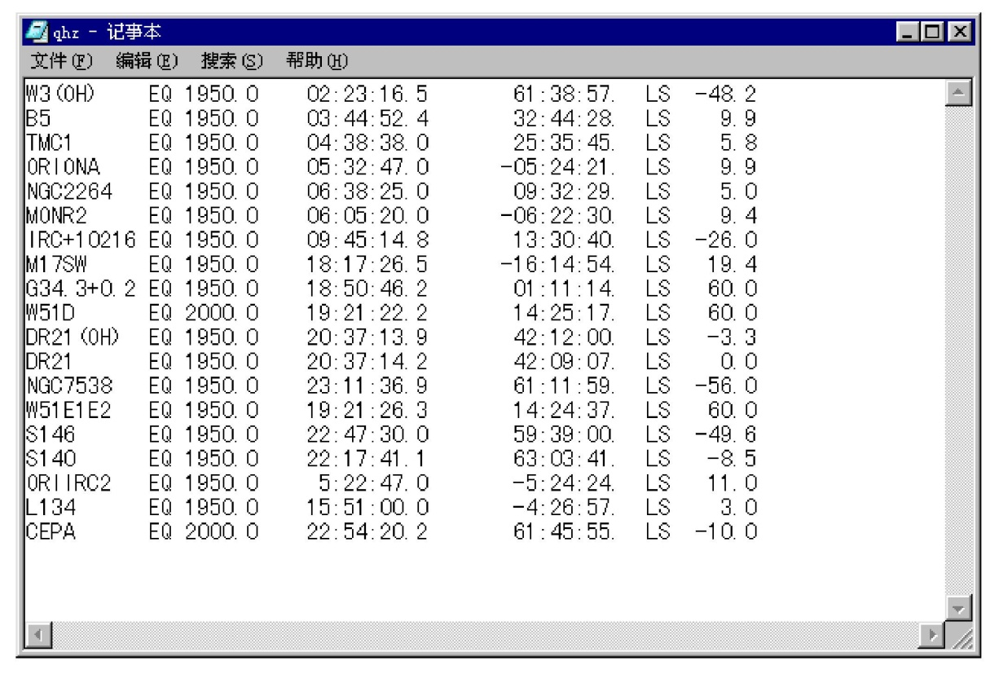

2. The conversion between the data

- FITS format data to class format file conversion
If you want to deal with the data format for the standard single-line FITS format, the use of CLASS software processing, the need to FITS format first converted to class format file, in the class software under the following procedures:

A, through http://www.radioast.nsdc.cn/tools.php Download the script file under different operating systems;
B, FILE OUT filename SINGLE // Initialize the file filename, in order to save the converted data;
C, @fits2bur.pro (Window system) or @wfits (Linux system) / / need to pay attention to the implementation of Linux, you must ensure that the wfits file has executable permissions, if no command chmod a+x wfits to add the implementation of the authority ;

2) class generated cube data and FITS file between the conversion
After processing the spectral data with class, the generated lmv, gdf and other cube data into FITS format file, on the contrary, the FITS format file into a class format file to deal with are easier.

A, cube data to FITS file conversion
VECTOR\FITS outfile.fits FROM inputfile.gdf (or inputfile.lmv)
B, FITS data to cube file conversion
VECTOR\FITS outfile.fits TO inputfile.gdf (or inputfile.lmv)

3. CLASS command
CLASS is the processing of spectral data, such as interception, polynomial fitting, GAUSS fitting, get spectral line information, output graphics files.

1), the basic order
DEV I W/B // Open a black / white graphics window
FILE IN filename // Open the file filename
FIND // the data is transferred to the cache
LIST // Lists the main header information for all find data
GET n (n for SCAN) // Read data with SCAN number n
PLOT // Draw the data lines in the graphics window
SET LINE 13CO (1-0) // Set the line name to be processed
SET SOURCE oriona // Set the data target name to be processed
SET OBSERVED 15-JUN-2002 // Set the date of the observation data
SET ANGLE SECONDS // Set offset in units of seconds
SET PLOT H // Set the line graph to be displayed in a histogram
FIND /OFFSET 0 0 // Find all spectral data with offset (0, 0)
AVERAGE // stacks multiple lines of the same location (averaging) or different bits Set the line of the superposition, but before the need to add the command SET NOMATCH
HARD filename /DEV PS FAST (COLOR) // Save the line data of the graphics window as ps file
SET SYSTEM E 2000 (E 1950 or G) // J2000, B1950, silver channel coordinates and so on
SET FORMAT L (L, B, F) // Set the line information to be displayed
SPECTRUM Yoff // Draw the following figure:

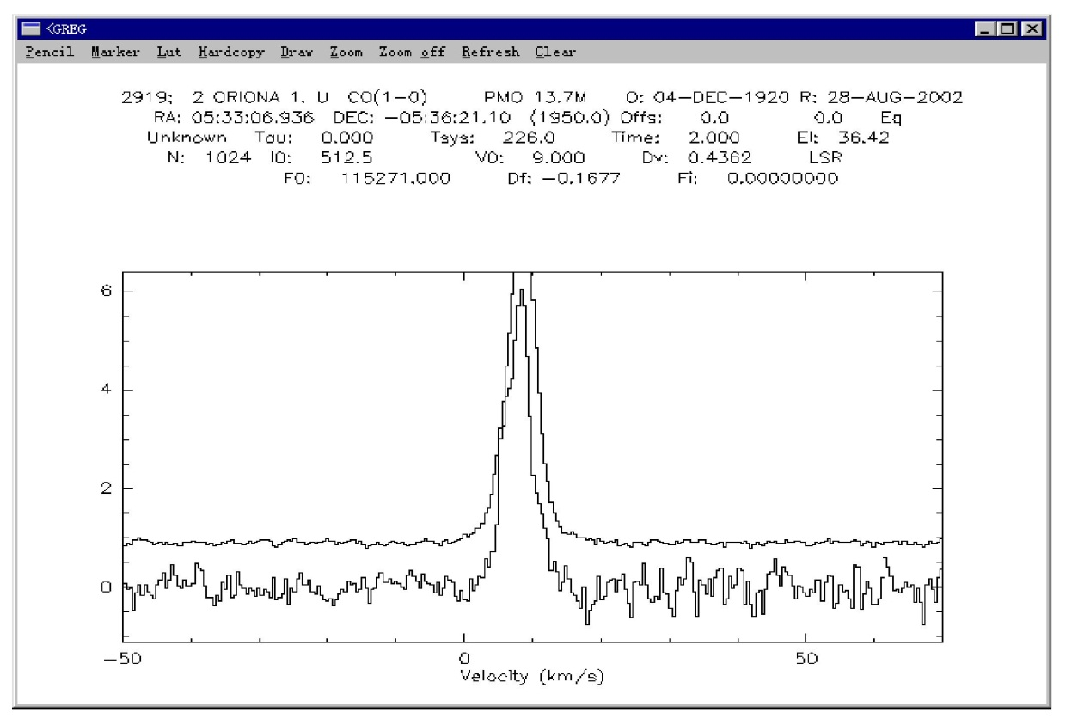

STAMP 5 5 /num // Draw the following figure:

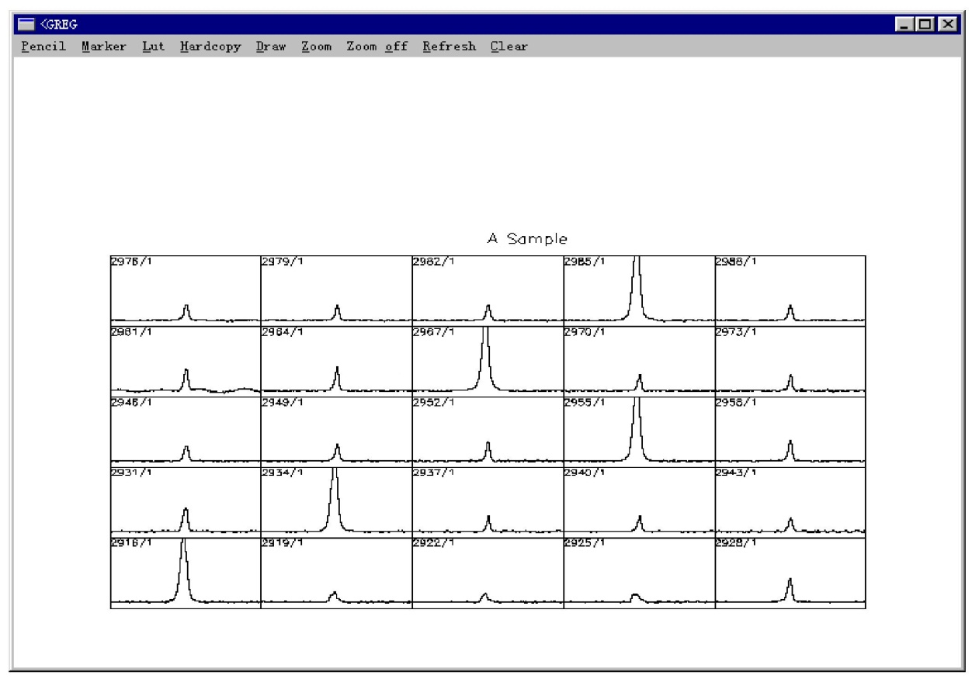

EXIT // exits the CLASS program

2) polynomial (spectral line baseline) fitting

SET MOD X n1 n2 // intercepts the line n1 ~ n2 of the X axis
SET MOD Y n1 n2
SET MOD Z n1 n2 // Select the line data from the range n1 ~ n2, usually in PLO /INDEX
SET WIN m1 m2 … // set the polynomial fitting range m1 m2, to avoid the signal to join the fitting
BASE n /PLOT // n polynomials fit and draw the fitting curve
PLOT // Confirm the line after the quasi-error is corrected

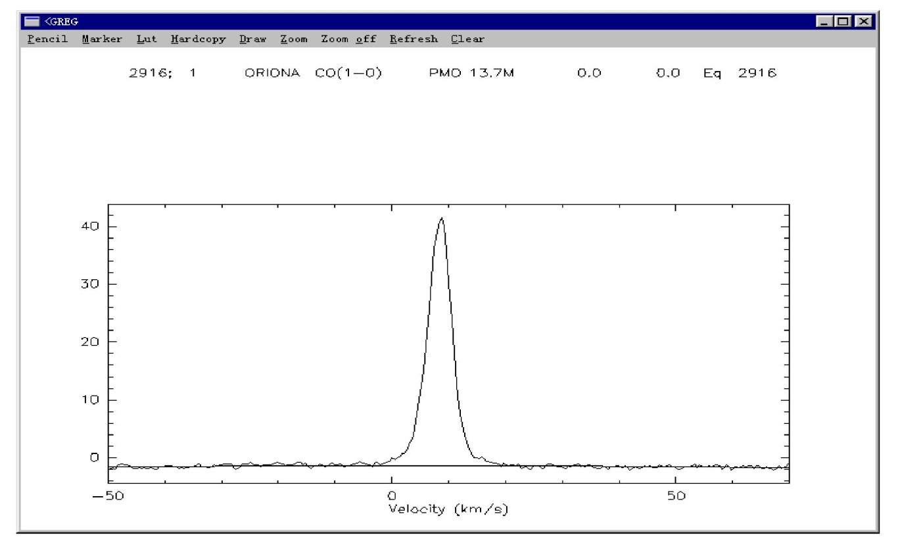

3) GAUSS fitting
LINE 0
MIN // for GAUSS fit
VISUALIZE // Draw the curve after GAUSS fit

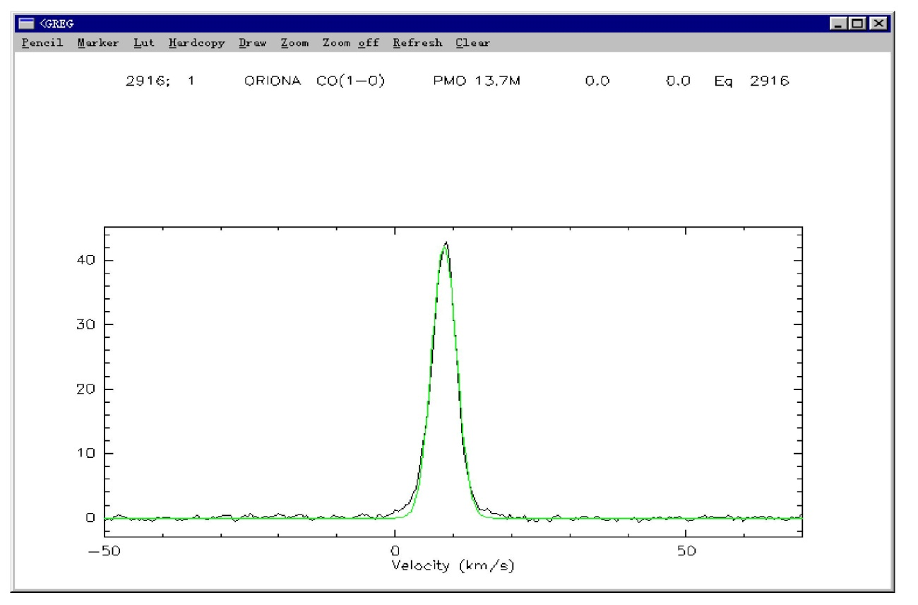

If it is bimodal or multi-peak spectral data, use LINE n; MIN; VISUALIZE.
For example: the following spectrum by three peaks fit.

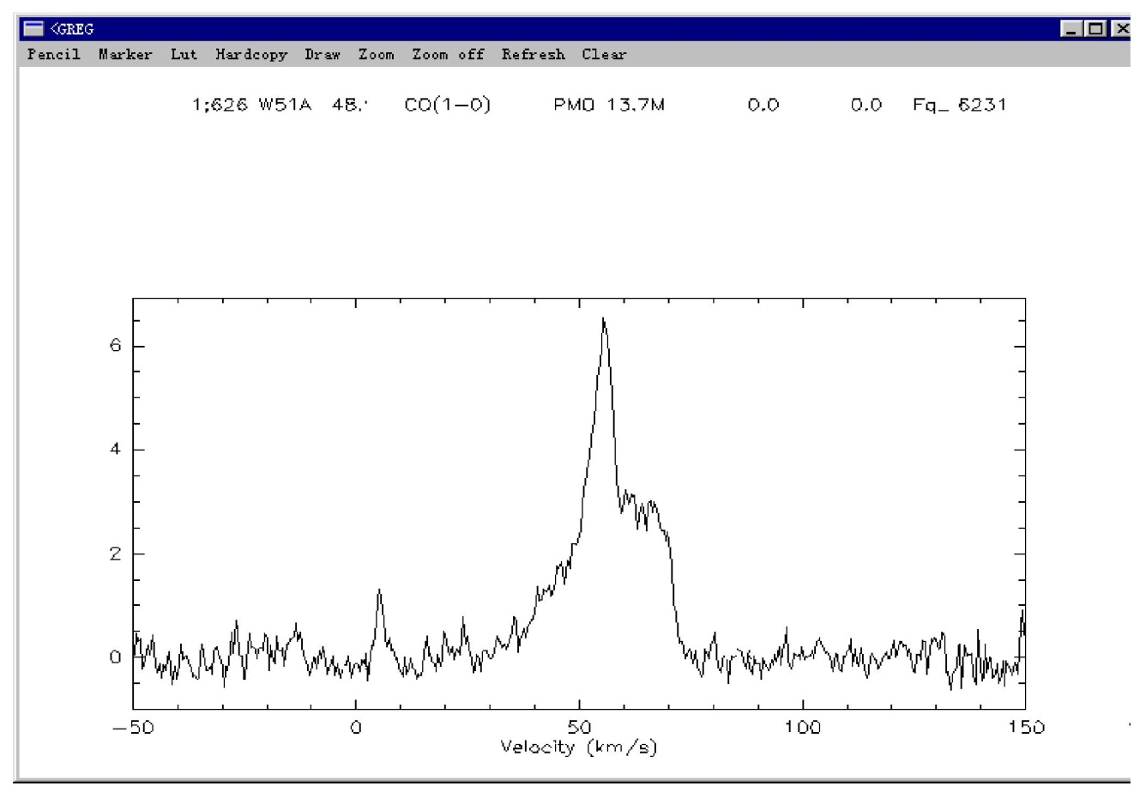

LAS> LINE 3

Line 1: 0 0.000 0 0.000 0 0.000
Line 1: 0 1 0 5 0 5

Line 2: 0 0.000 0 0.000 0 0.000
Line 2: 0 6 0 50 0 13

Line 3: 0 0.000 0 0.000 0 0.000
Line 3: 0 3 0 65 0 10
Where the second column shows the intensity; the fourth column shows the position where the line is located; the sixth column shows the line half width , You can also enter the above parameters into a file, read with the command
LINE /INPUT filename, this is suitable for the same batch of data processing.

LAS>MIN

LAS>VISUALIZE
The results are as follows:
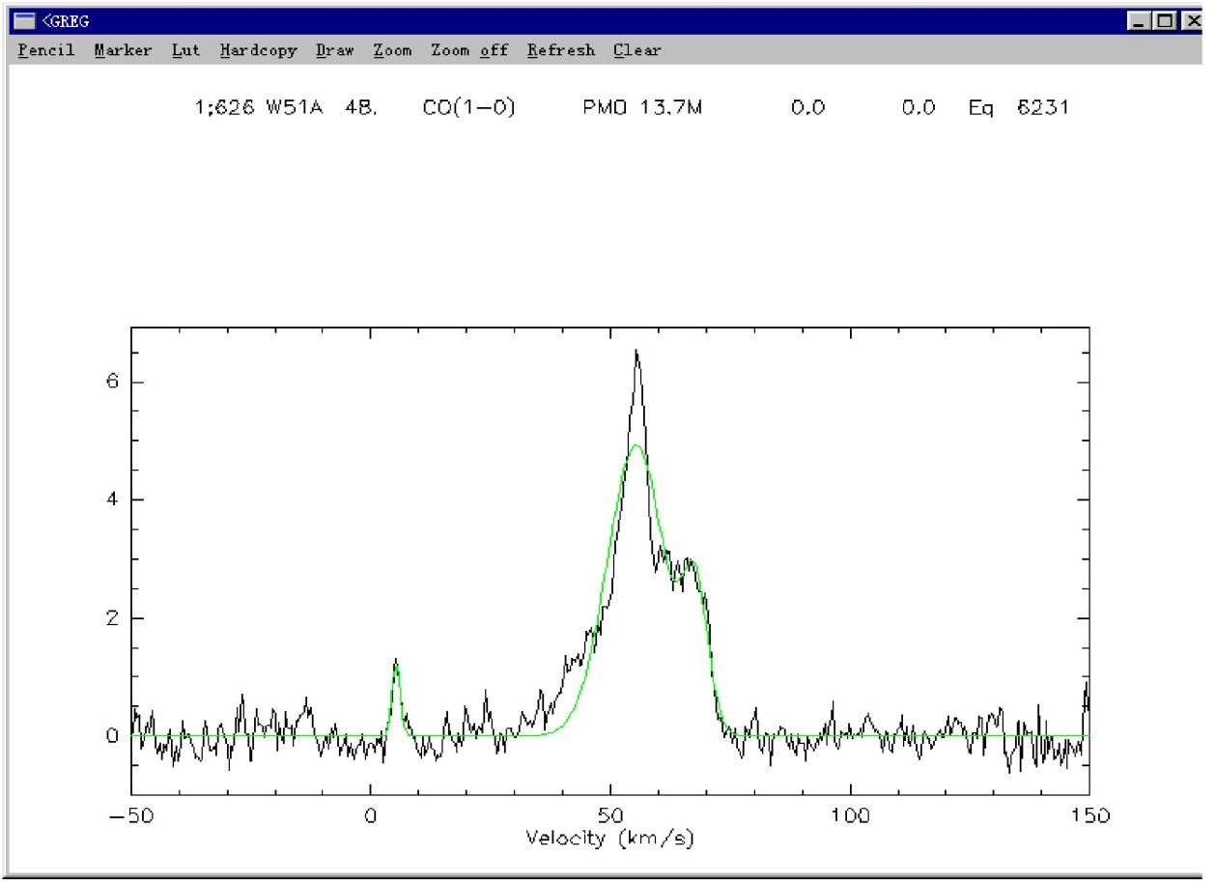

For a special spectral data, you can set METHOD arg directly, where arg includes SHELL, NH3 (1,1), NH3 (2,2), NH3 (3,3), HFS filename, CONTINUUM, and so on.

4) GRID processing of the relevant orders

LET MAP%BEAM * // Set the beam of the telescope

TABLE filename1 NEW (or OLD) // Create an index table
XY_MAP filename1 // GRID calculation

This set of commands can also write the line data you process as a cube file and convert it to a FITS format file. XY_MAP after the data for the gdf file, class can not read directly, if you would like to write the file class readable line data, further processing, analysis, need to go through two steps.

FILE OUT filename SINGLE

LMV filename1
Class provides a number of view cube file task, you can easily view the data you are dealing with the results.

LET NAME filename1

LET TYPE LMV ( GDF )

GO VIEW
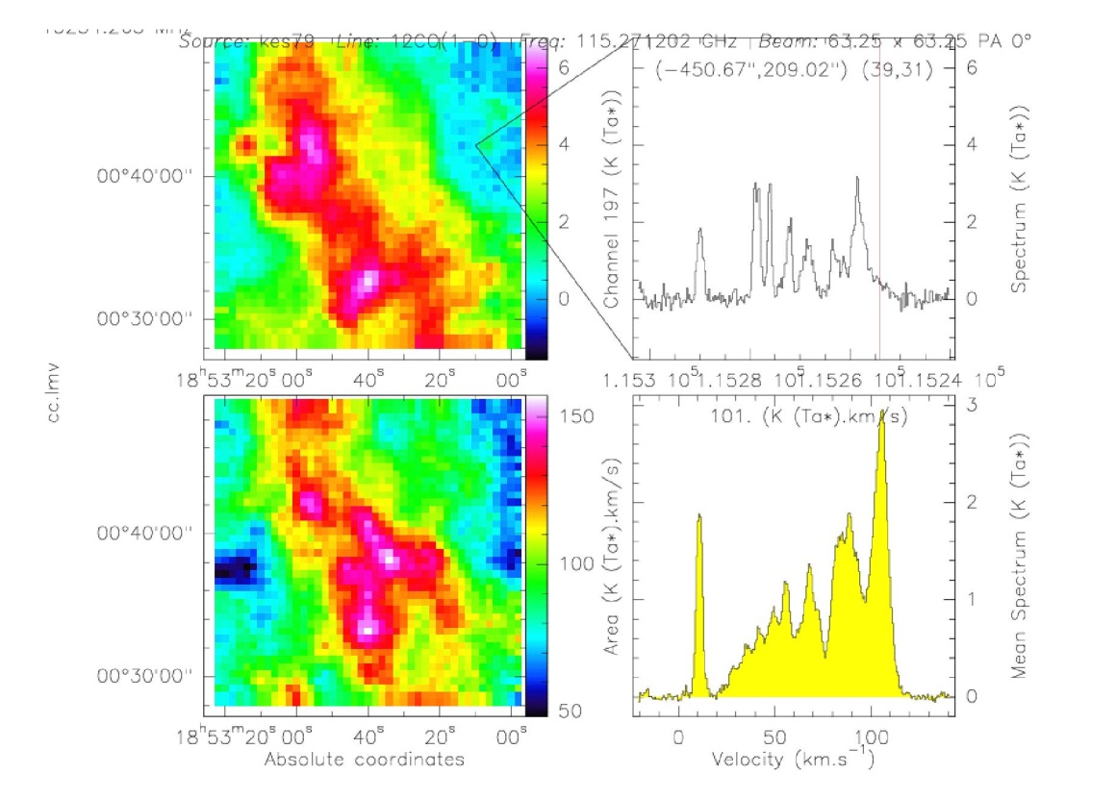

GO 3VIEW
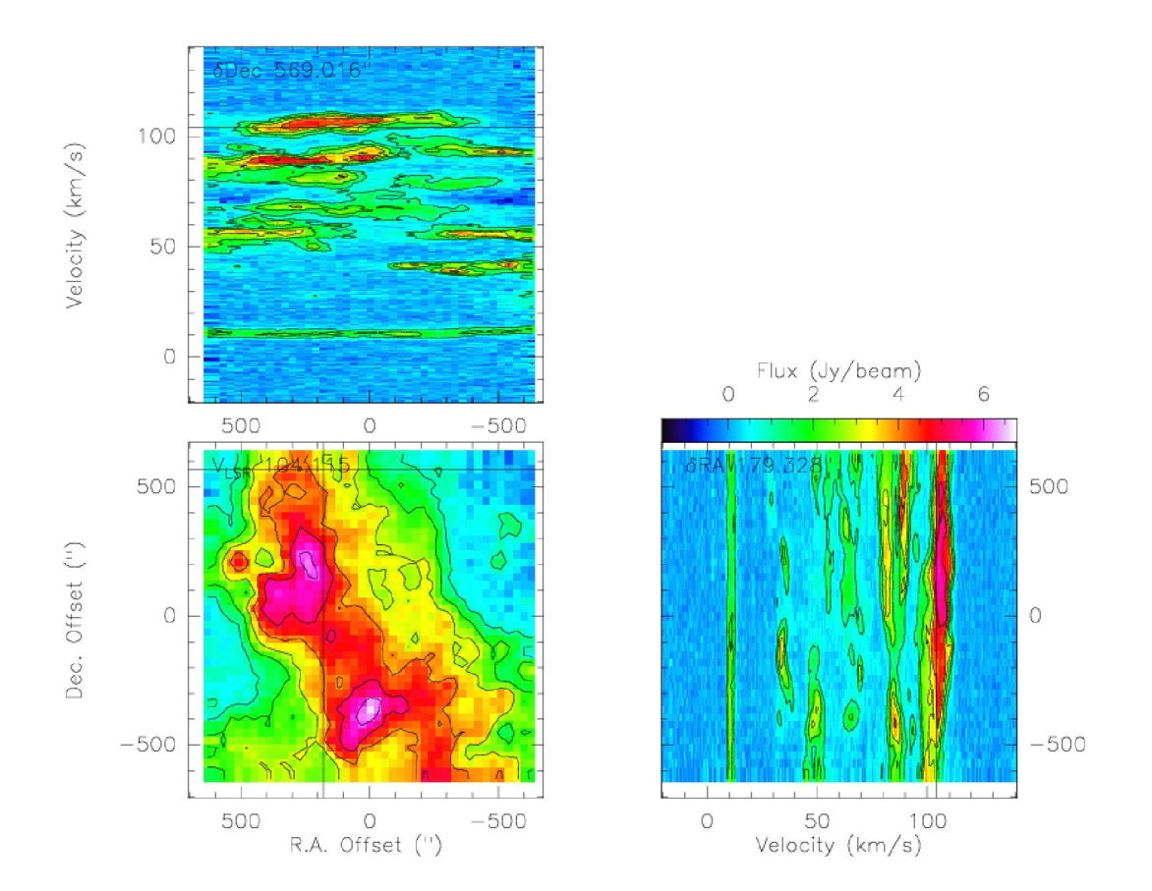
GO WHERE

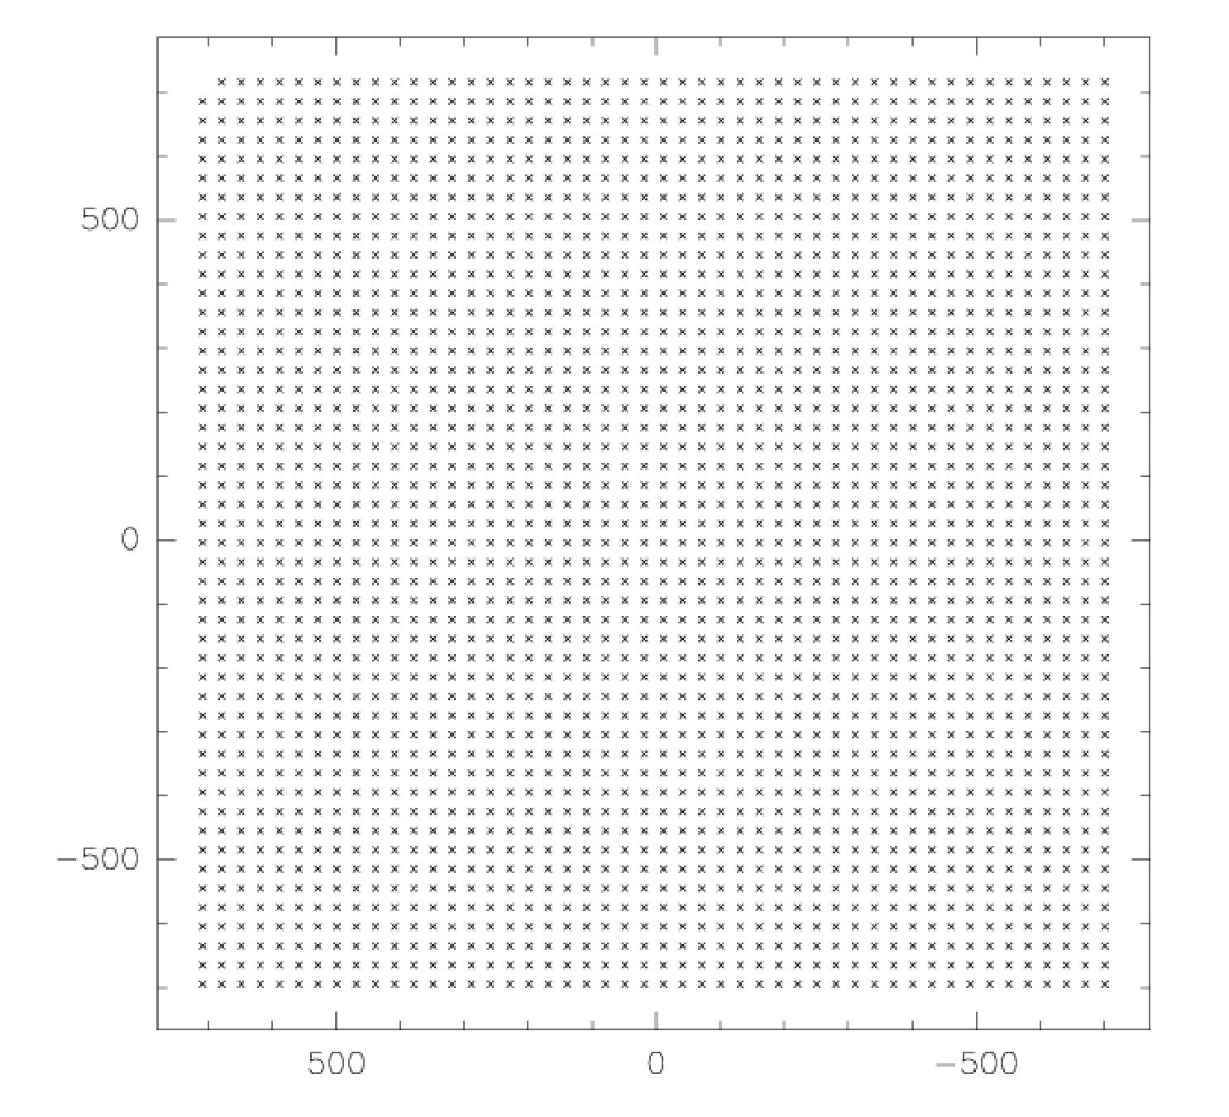

GO BIT

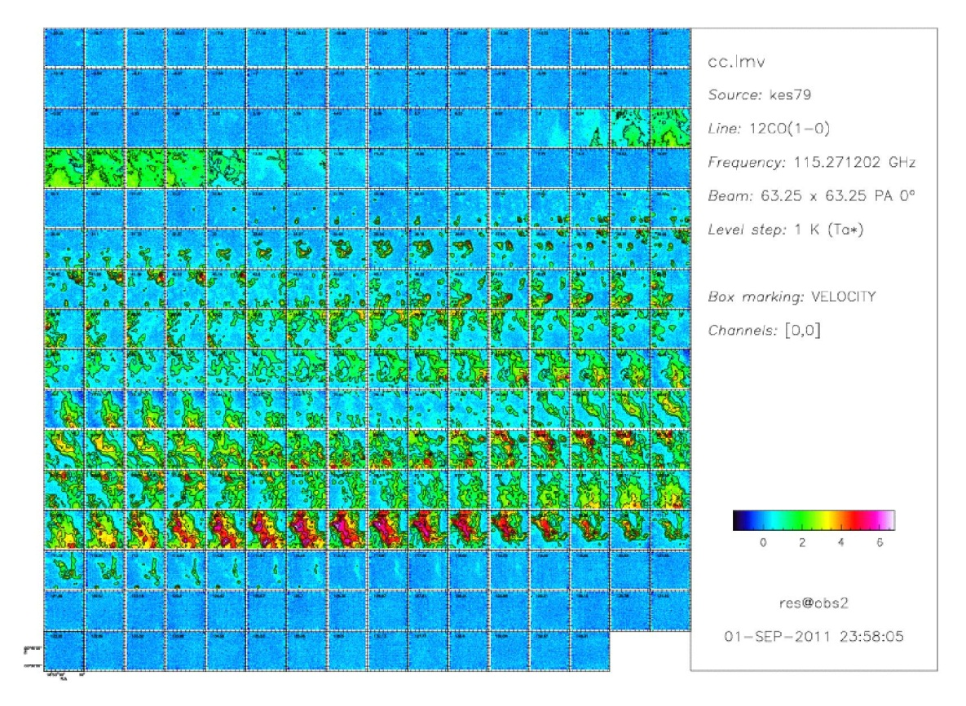

GO SPECTRUM

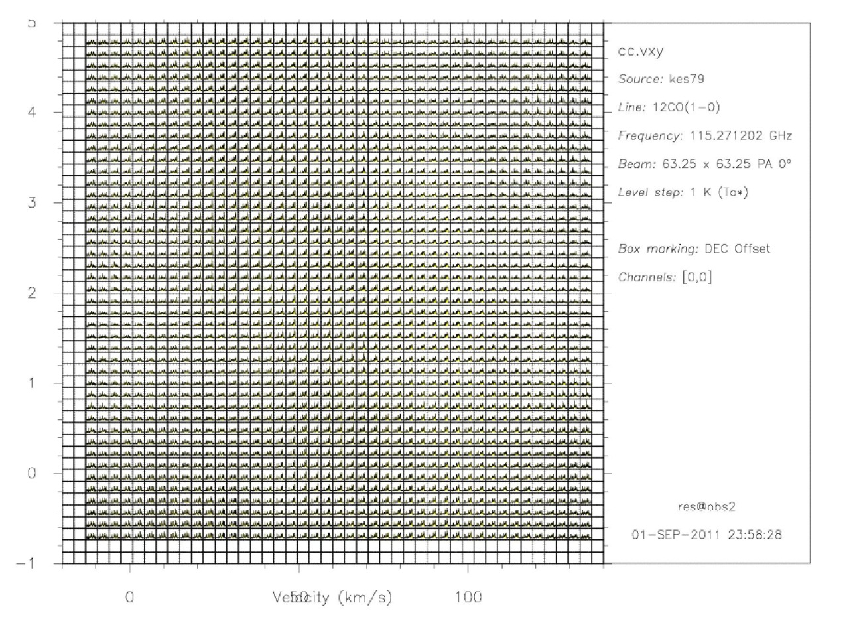

LET ANGLE 45

GO ROT

GO VIEW
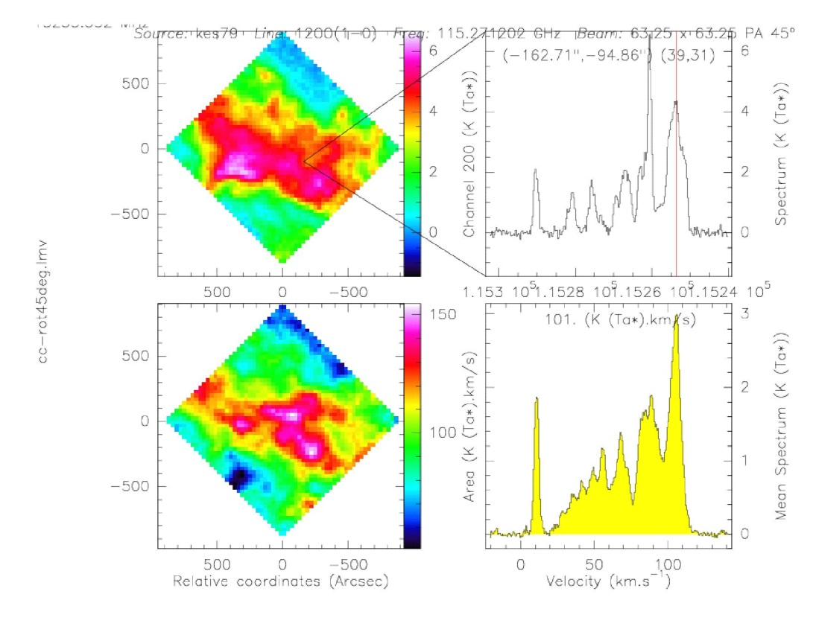

5) the output file

FILE OUT filename SINGLE // Initialize a filename file
WRITE // Write FIND, GET data to filename
PRINT AREA n1 n2 /OUTPUT filename // The integral area between the spectral data rates n1 ~ n2. Output to file filename
SAVE filename // all the settings that were previously knocked to the file, the next time you can use as a macro to tune
Use the following documents:

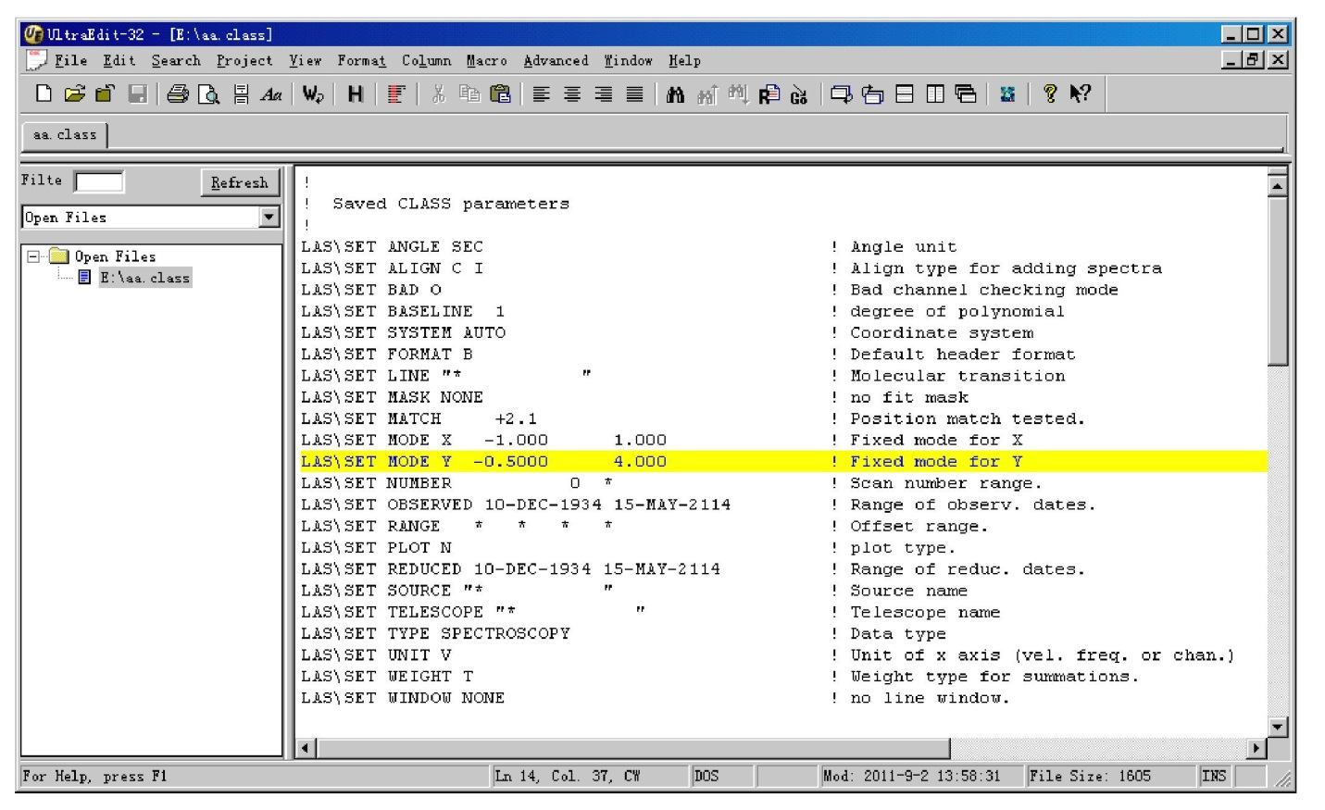
6) Some other commands:

MODIFY // // Modify the line information of the line data, such as center channel, speed, source frequency, and so on the following commands are used to set the control action when processing data:

SET BAD Check
SET BASE arg
SET CUR Arg
SET MASK [m1 m2 [… . .]]
SET WIN [w1 w2 [… …]]
SET NOMATCH
SET MATCH Tol

The following commands are used to set the data to be displayed in a different way:
SET FORMAT Type
SET SYSTEM Type [E, G]
SET UNIT Lower [V, C, F]

The following command is used to set the search mode:
SET NUMBER n1 n2
SET RANGE west east south north
SET TELESCOPE name

If you want to batch processing a lot of lines, you can use the FOR loop statement, you can also execute the language
Write the file as a file, and then execute the command: LAS>@ filename

For example, for many lines of polynomial batch processing, first set the scope of the fit, and then the following statement:

LAS> FOR I 1 TO FOUND

LAS: GET N

LAS: BAS 1 // (You can also use the higher order, it is recommended to use 1 item)

LAS: NEXT

When you are dealing with data, sometimes you may want to see some information at any time, but after you type the command LIST, all the data is displayed. At this point you can use the command LIST /OUTPUT filename to save it as a file, and then open the file as a file, and browse to see the information you need.

4. GREG command
GREG is the data processed by CLASS, the image analysis and processing.

COL X n1 Y n2 Z n3 /FILE filename // According to the data X, Y, Z of the read file filename

LIM /REV X // Defines the border of the graph and inverts the X axis

LEV 1 TO 7

RAND 100 100 /BLANKING -1

RGMAP /PER 10 // Draw a contour map at 10% of the maximum value

BOX // Draw a border, ruler

LAB “R.A.” /X // Indicates the meaning of the X axis

LAB “DEC.” /Y // Indicates the meaning of the Y axis

As shown below:

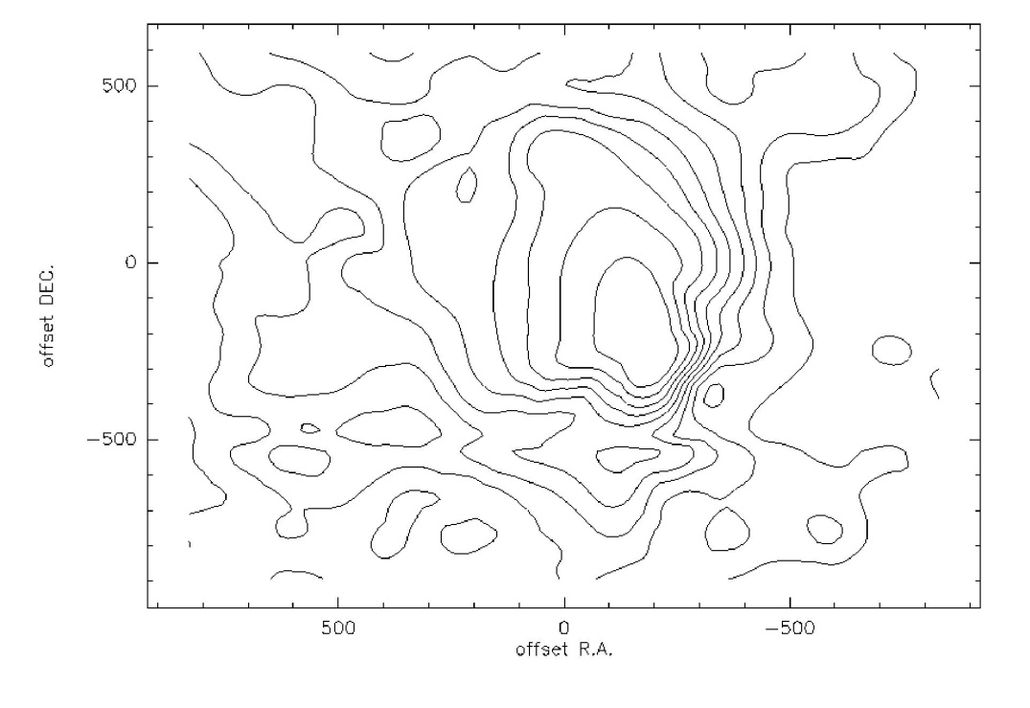
When you run the GILDAS software, you do not need to exit the running program to execute LINUX or MS-DOS commands, such as: To list the files in the current directory, you can execute the command SYS “ls -1” or SYS “dir”.

For more detailed manuals please click on the website:
http://iram.fr/IRAMFR/GILDAS/
When using these software, you can also use the help command command at any time, you use the command method (meaning).

Example:
The following to a data file, for example, to illustrate the polynomial fitting, Gaussian fitting, and finally make the contours of each step process.

Under the CLASS software:
Dev I w

File in qhz14.m

Find

Set ang min

Set plo h

Set source 0145+000

Set line 12CO*

Get f

Plo

Set mod x -50 120

Plo

Set win -10 80

Bas 1 /plo

Plo

find

Sic del qhz.bas // Before creating a new file, make sure that no file name exists

File out qhz.bas s

For i 1 to found

Get n

Bas 1

Write

Next

File in qhz.bas

Find

List

Get f

Set mod y -5 30

Map /gr

The following results were obtained:

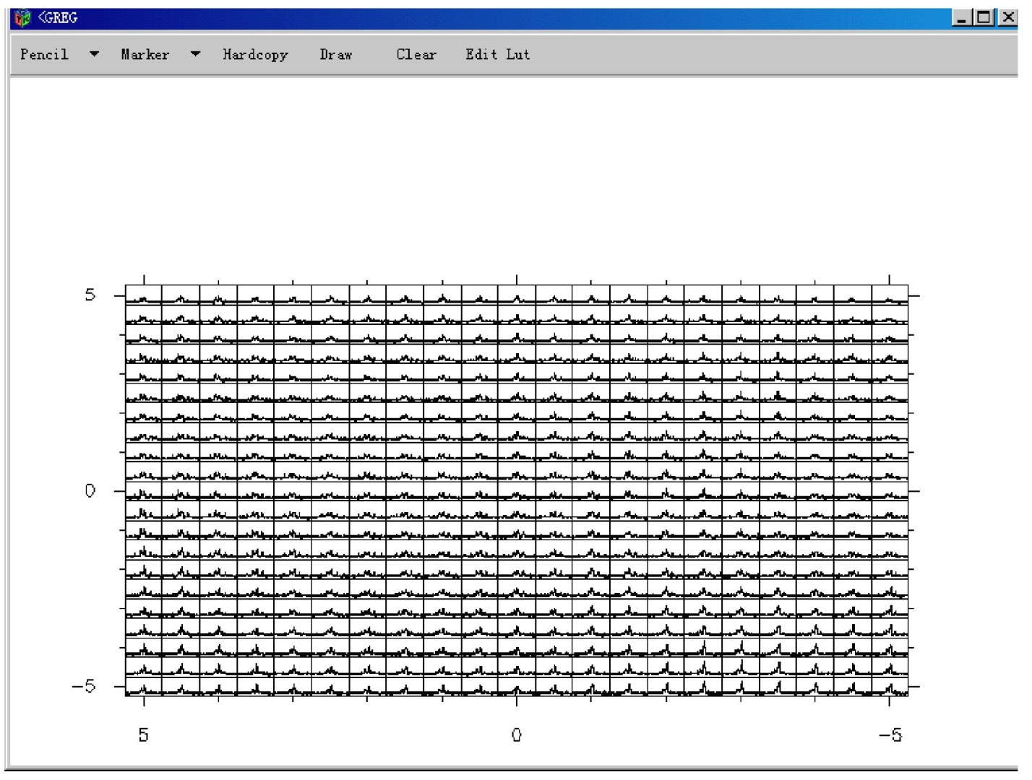

Get f

Plo

Line 4 // Select the range of gauss fit spectral lines

min

Vis

The results are as follows:

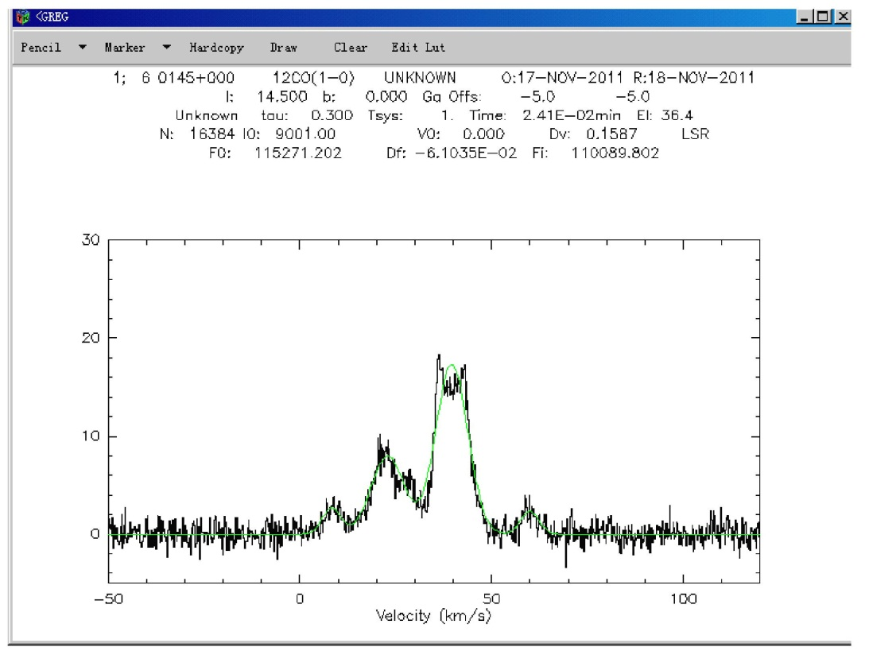
File in qhz.bas

Find

List

Sic del qhz.dat

Print area -3.96 52.9 /output qhz.dat

Because this source has three ingredients, you can map the two components

Sic del qhz1.dat

Print area -3.96 13.0 32.07 52.9 /out qhz1.dat

!************************************
The following operations need to be performed under the Gildas / GREG package

!************************************
Under the GREG software:

Dev I w

Col x 2 y 3 z 4 /file qhz.dat

(The file qhz.dat in the same coordinates of the data deleted, leaving only one of them)
Set box m
lev 4 to 10
lim /rev x
rand 100 /blank -1 -1
rgmap /per 10
box
lab “\gDL (arcmin)’ /x
lab “\gDB (arcmin)’ /y
set mar 3 2 0.2
point

The final result is as follows:

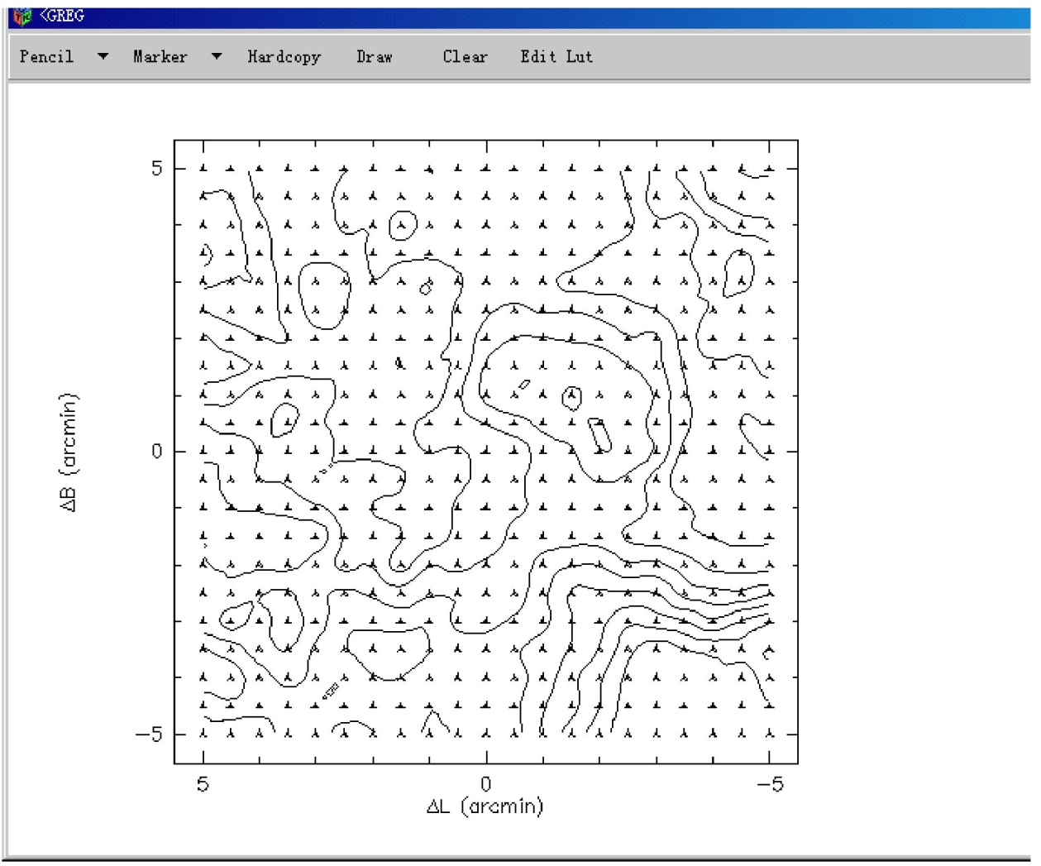

Or you want a color chart, please type the last command

plot

lut rainbow3 // Use lut to change the color

rgmap /per 10

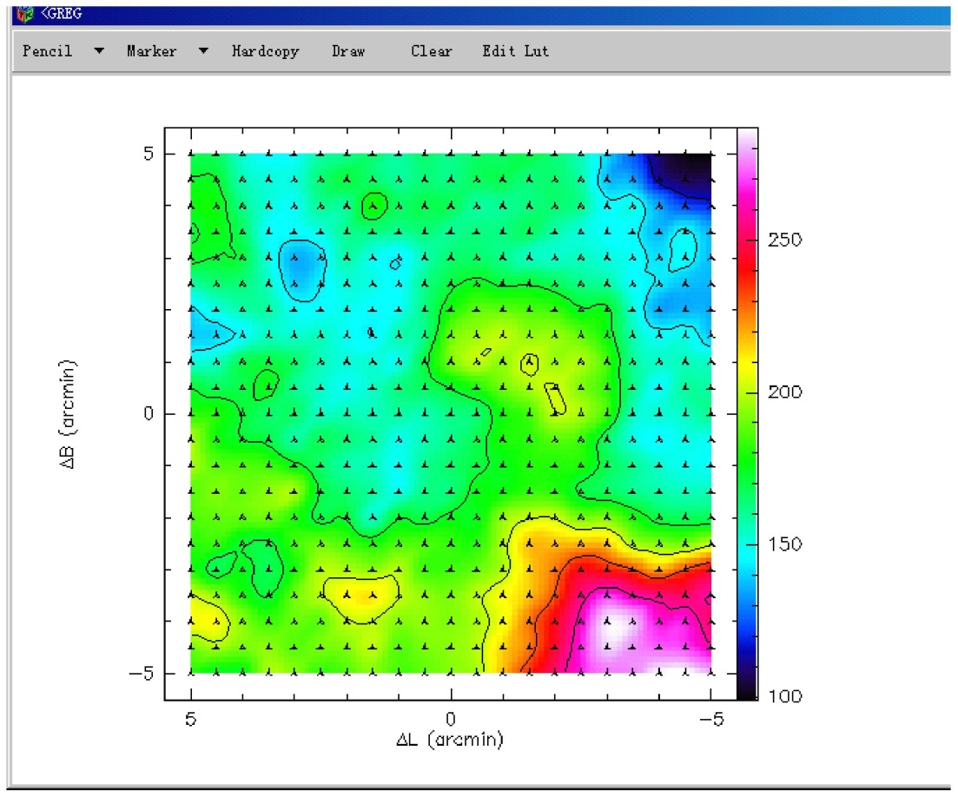

Finally, save the results as a file with the following command:

Hard qhz /dev ps fast (or colour)

Draw the three components and plot the first ingredient

col x 2 y 3 z 4 /file qhz1.dat

lim /rev x

lev 3 to 9

rand 100 /blank -1 -1

plo

rgmap /per 10

box

lab “\gDL (arcmin)” /x

lab “\gDB (arcmin)” /y

The final result is as follows:
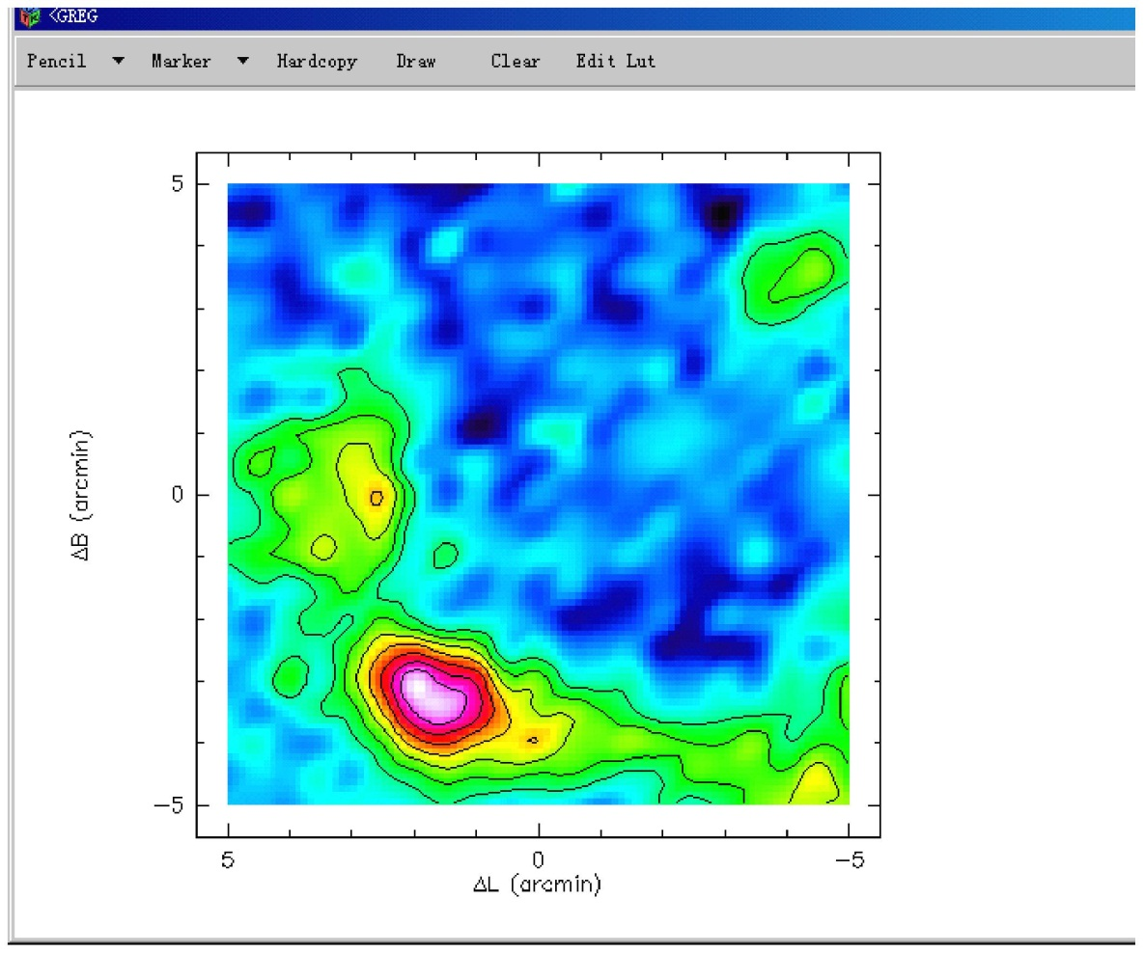

Plot the second ingredient

col x 2 y 3 z 5 /file qhz1.dat

lim /rev x

lev 3 to 9 by 0.5

rand 100 /blank -1 -1

plo

rgmap /per 10

box

lab “\gDL (arcmin)” /x

lab “\gDB (arcmin)” /y

The final result is as follows:

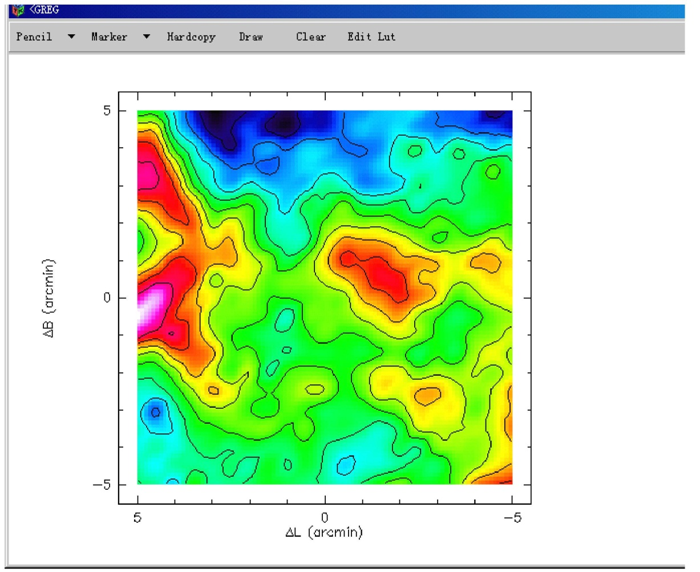

Plot the third ingredient

col x 2 y 3 z 6 /file qhz1.dat

lim /rev x

lev 3 to 9 by 0.5

rand 100 /blank -1 -1

plo

rgmap /per 10

box

lab “\gDL (arcmin)” /x

lab “\gDB (arcmin)” /y

The final result is as follows:

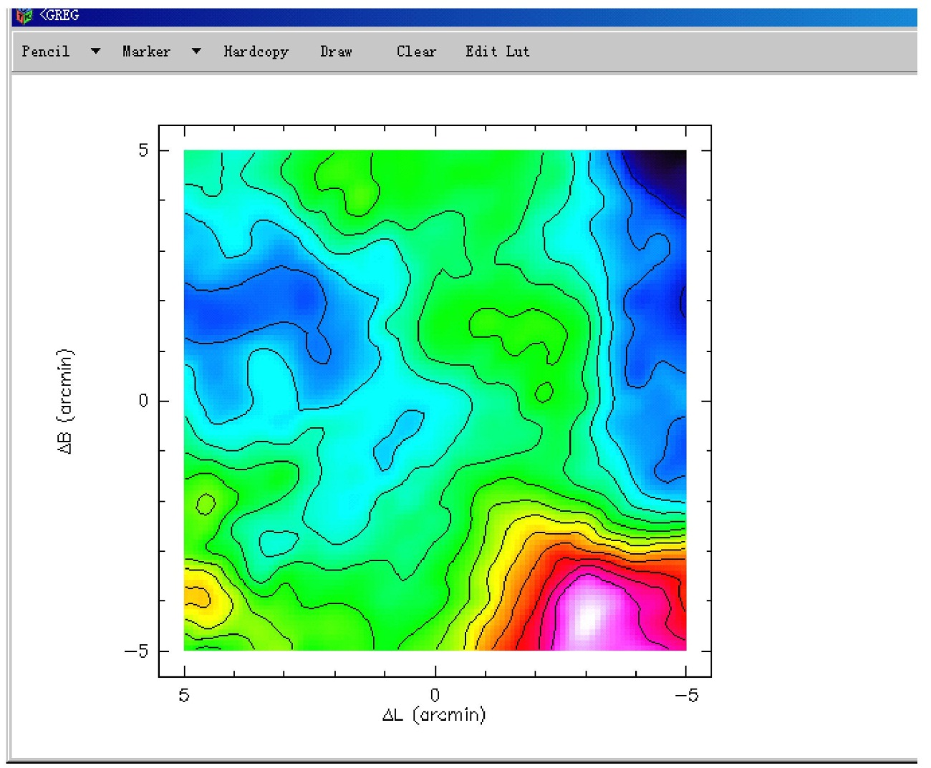
!**************************************************************
If you like to convert the data into FITS Cube format, and then analysis and processing, you can Gildas / CLASS under the following operations

!**************************************************************

File in qhz.bas

Find

Let map%beam 52

Let map%cell 30

Table qhz new /rang -3 33 v

xy_map qhz /nogrid

vector\fits qhz.fits from qhz.lmv

The following is the process for the speed _ position (Position-Velocity) map:

Use the command strip in the class to generate the qhz.gdf file

Execute the following command under greg

def image a qhz.gdf read

lim 0 50 * * /rgdata a

greg2\plot /sca lin 0 20

lev 1 to 10

rgmap /abs 2

lab “Velocity (km/s)” /x

lab “gDDEC. (arcmin)” /y

axis xl /unit r

axis xu

axis yl /unit m

axis yr

The final result is as follows:
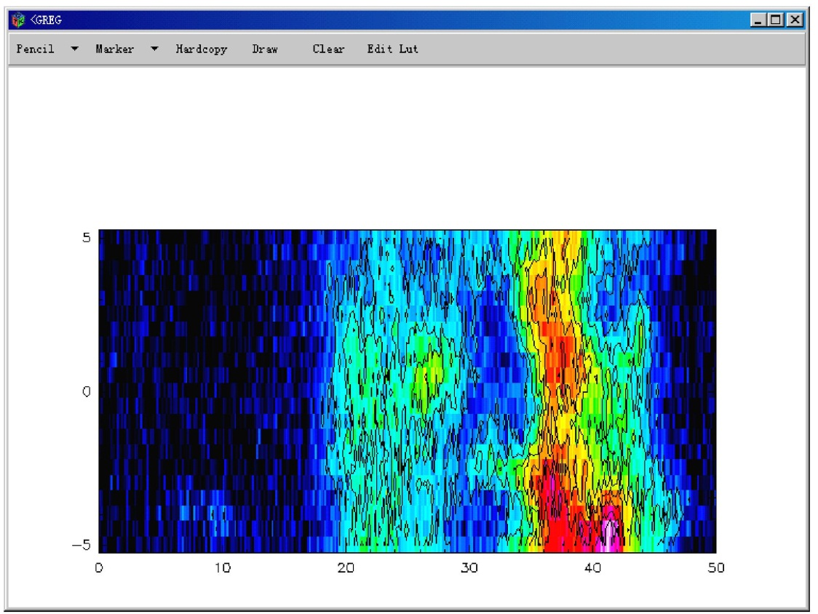

Observation study group
August 2011

